PCB Price Research

Overview:
The main PCB for all remote devices will be standardized at 2.5”x2.5”. The PCB will include a maximum of 6 layers. The PCB will be manufactured following the IPC 6012 Class 2 specification.

Cost Estimate:
https://www.pcbway.com/HighQualityOrderOnline.aspx
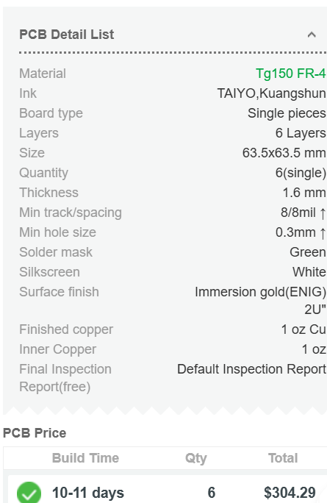

Author:
Luke Matthews
09/23/2025 4:30 PM - 4:45 PM

